DEPLOYEMENT OF APP IN IBM CLOUD - CONTAINERIZE THE APP
Date | 8 Nov 2022
Team ID | PNT2022TMID34668
 | Nutrition Assistant Application
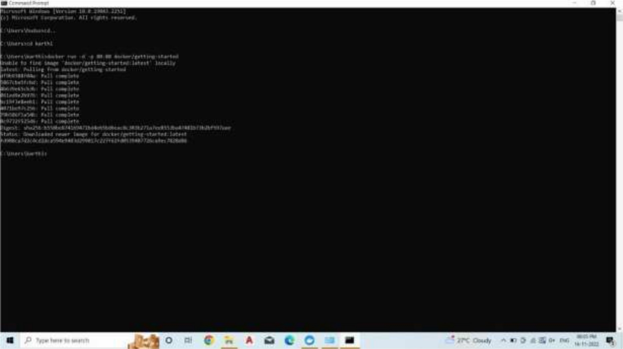
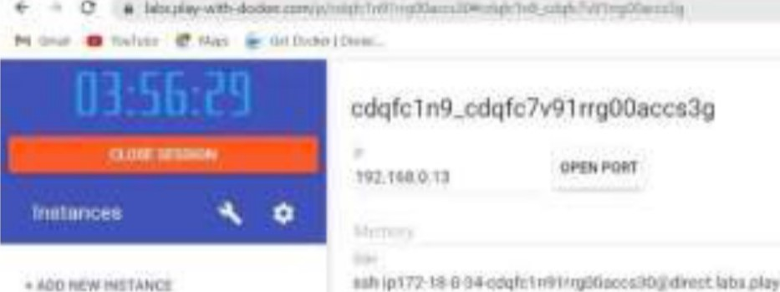 0
